**Create the terraform deployment to host a stateless application**

1. I use ec2 linux server to run the application. (hostname as a swapnil)

(Install terraform, docker in linux)

Created terraform script as below:

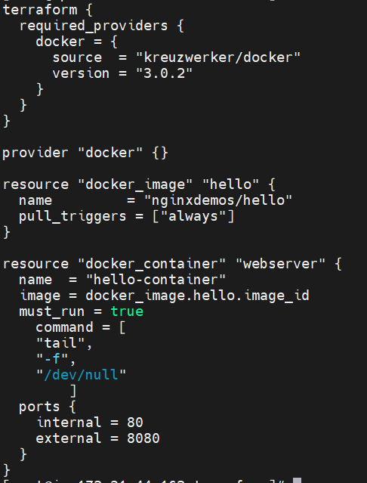

Output of the script is running container of nginxdemo/hello image. Also bind port 8080 for that container.

(Port should be open in security group of ec2 to access that application from URl)



**2 .**

To create a infrastructure for hosting a application and to secure it we can use different services of AWS Cloud.

* WAF (Web application firewall)
* VPC (To create isolated environment for application)
* Subnet ( Private subnet for backend and database and public subnet for front end application )
* NACL (First level firewall for subnet level which controls inbound and outbound traffic)
* Security group ( To control specific port allocation and type of traffic allow)
* ALB (application load balancer)

**Create the architecture diagram**

Install diagram on my instance using

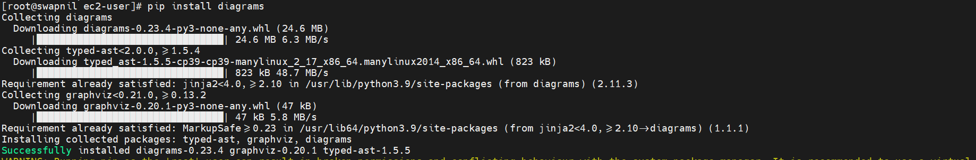

Then using a script I create a architecture diagram which is shown below:

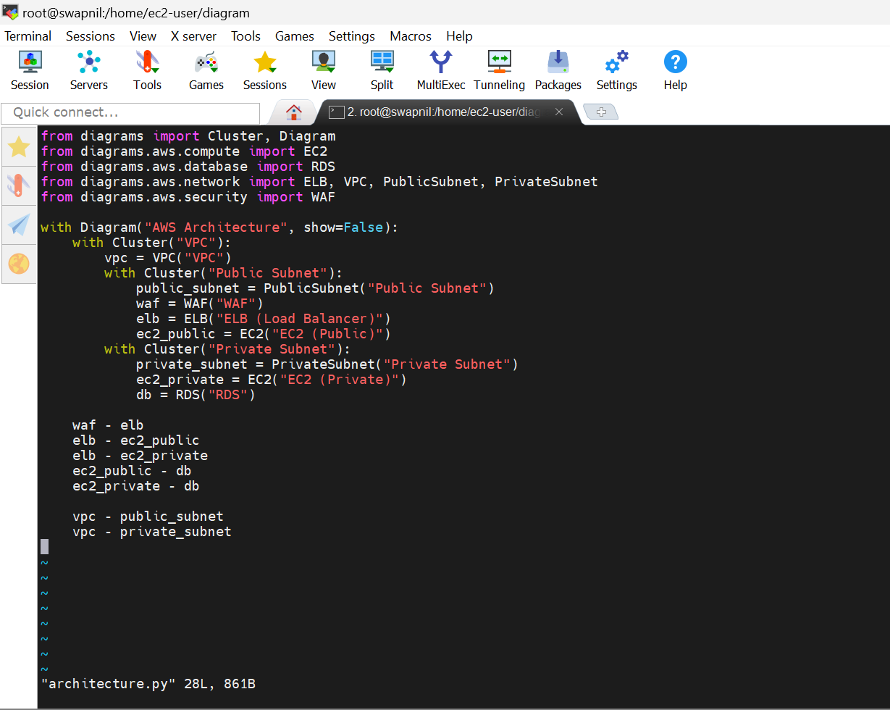



Output of the script is as below:

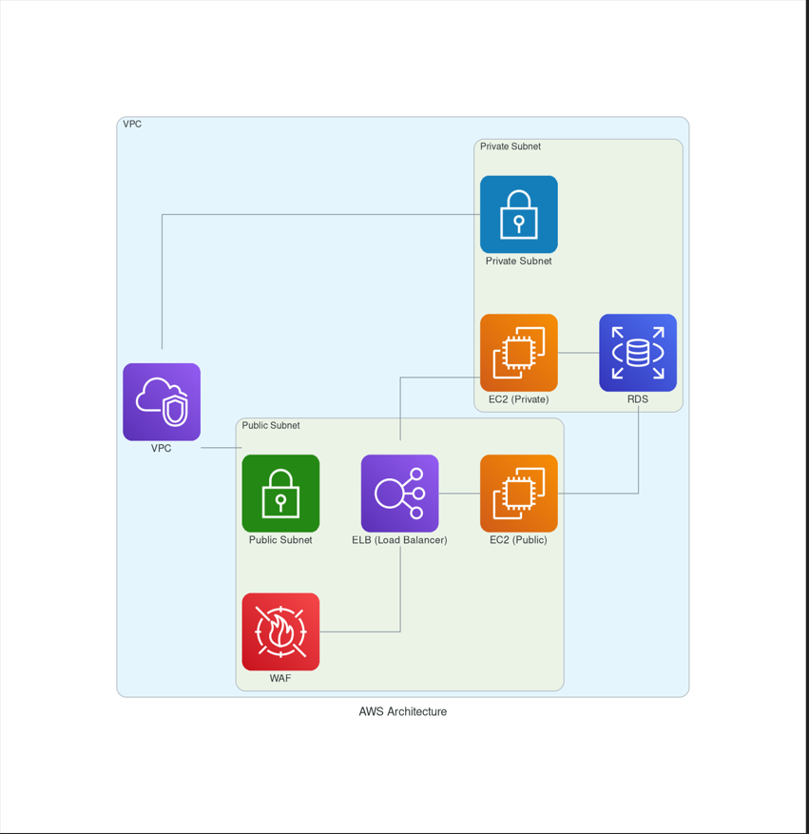

(Thera are many service needed to create an architecture but due to many missing component in diagram library I am building the small example using script)

**The actual infra that I am aware of is like below**

**(source : aws official site)**

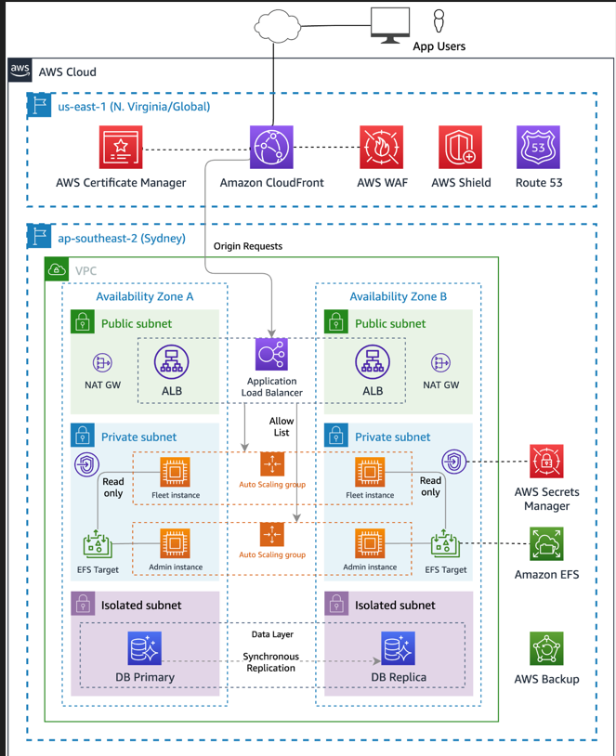

**Services include and I am having knowledge of**

AWS WAF, VPC, subnet, nacl, ec2, RDS, IAM, EFS, gateway(internet gateway, nat gateway) etc.